Feature Testing

Team 16:

Raghav Gupta

Chelsea Jaculina

Bala Nyan Kwaw

Mike Lee

Yihua Li

**April 29th, 2018**

**Professor Badari**

**CMPE 187**

# Table of Contents

**Table of Contents** **1**

**Overview** **2**

Introduction 2

Purpose 2

**Problem Layout** 3

**Oracle**

Features 5

**Testing Methodology**

**Test Cases**

**Lessons Learned**21

# 

# Overview

## Introduction

In this project, we are asked to choose a mobile application that we are not familiar with or download a new one that we have not heard of before but may be useful to have. We were asked to make a list of features that we will test, describe the input domain and explain if the boundary values exists or if equivalence partitioning is possible for it. In addition to creating a list of features we were also asked to create five or more test cases for each feature. We were then asked to describe the input values and then list out the steps we needed to take (enter text, press button, etc.) and explain the expected output (values or state change). We then needed to create a table showing test cases, inputs, expected output, actual outputs, and if the test passed or failed.

## Purpose

The purpose of this project was to use the technique of Feature testing. Feature testing is considered to be a testing methodology in where modifications of an existing functionality is made or a new functionality is added. In this software testing technique, it should cover all types of scenarios. For our team to understand how feature testing works, we must generate a list of features for a mobile application while also describe the input domain and explain any boundary values or equivalence partitioning. In addition, we need to also practice writing test cases and include any required diagrams such as state transitions, decision tables, or GUI transitions.

# Problem Layout

**Target Application:** AMC Theatres on iOS and Android

The team chose AMC Theatres as their target application for feature testing as this is an application no one in the team has used and the application sounded exciting to test and use. The application can be used for free to search for movie showings or users may create a membership. The user may choose a free membership or upgrade to a premiere membership which the user to pay $15/ month to subscribe. The users are then provided a free movies at partner theaters with the restriction of watching four movie a month.

The problem layout of this project includes five main components.

1. Choosing a mobile application that our team was not familiar with or download a new on that we have not used or heard of before.
2. Generate a list of features that needs to be test and describe the input domain and explain if any boundary values exist or if equivalence partitioning is possible for it.
3. Create 5 or more test cases for each feature you are testing and first describe the input values, steps that are required to take (enter text, press button, etc.), and explain expected output (values or state changes).
4. Create a table showing test cases, inputs, expected outputs, actual outputs, and if the test pass or fails.
5. Include any of the following upon relevancy:
   * State Transition Diagram
   * Equivalence Partitioning
   * Boundary Values
   * Screenshots/GUI Transition
   * Decision Table

# Oracle

## Test Oracle

### Environment

The hardware used for programming and testing is an iPhone running the operating system of iOS 11.3. The program used for creating the State diagram was draw.io (a plugin by Google) and Code2flow ( <https://code2flow.com/app> ) for verification of the diagram through a third party software.

### Strategy

The strategy that our team will perform is by testing through each feature that we generated and enter each of the inputs for every different test case.

### Features

The four features that our team will be testing are of the following

1. Starting a membership
2. Logging in
3. Browsing for movie
4. Buying a movie ticket

## Starting a Membership

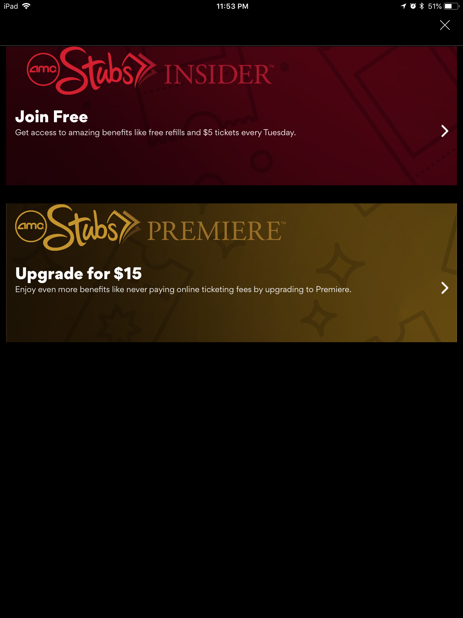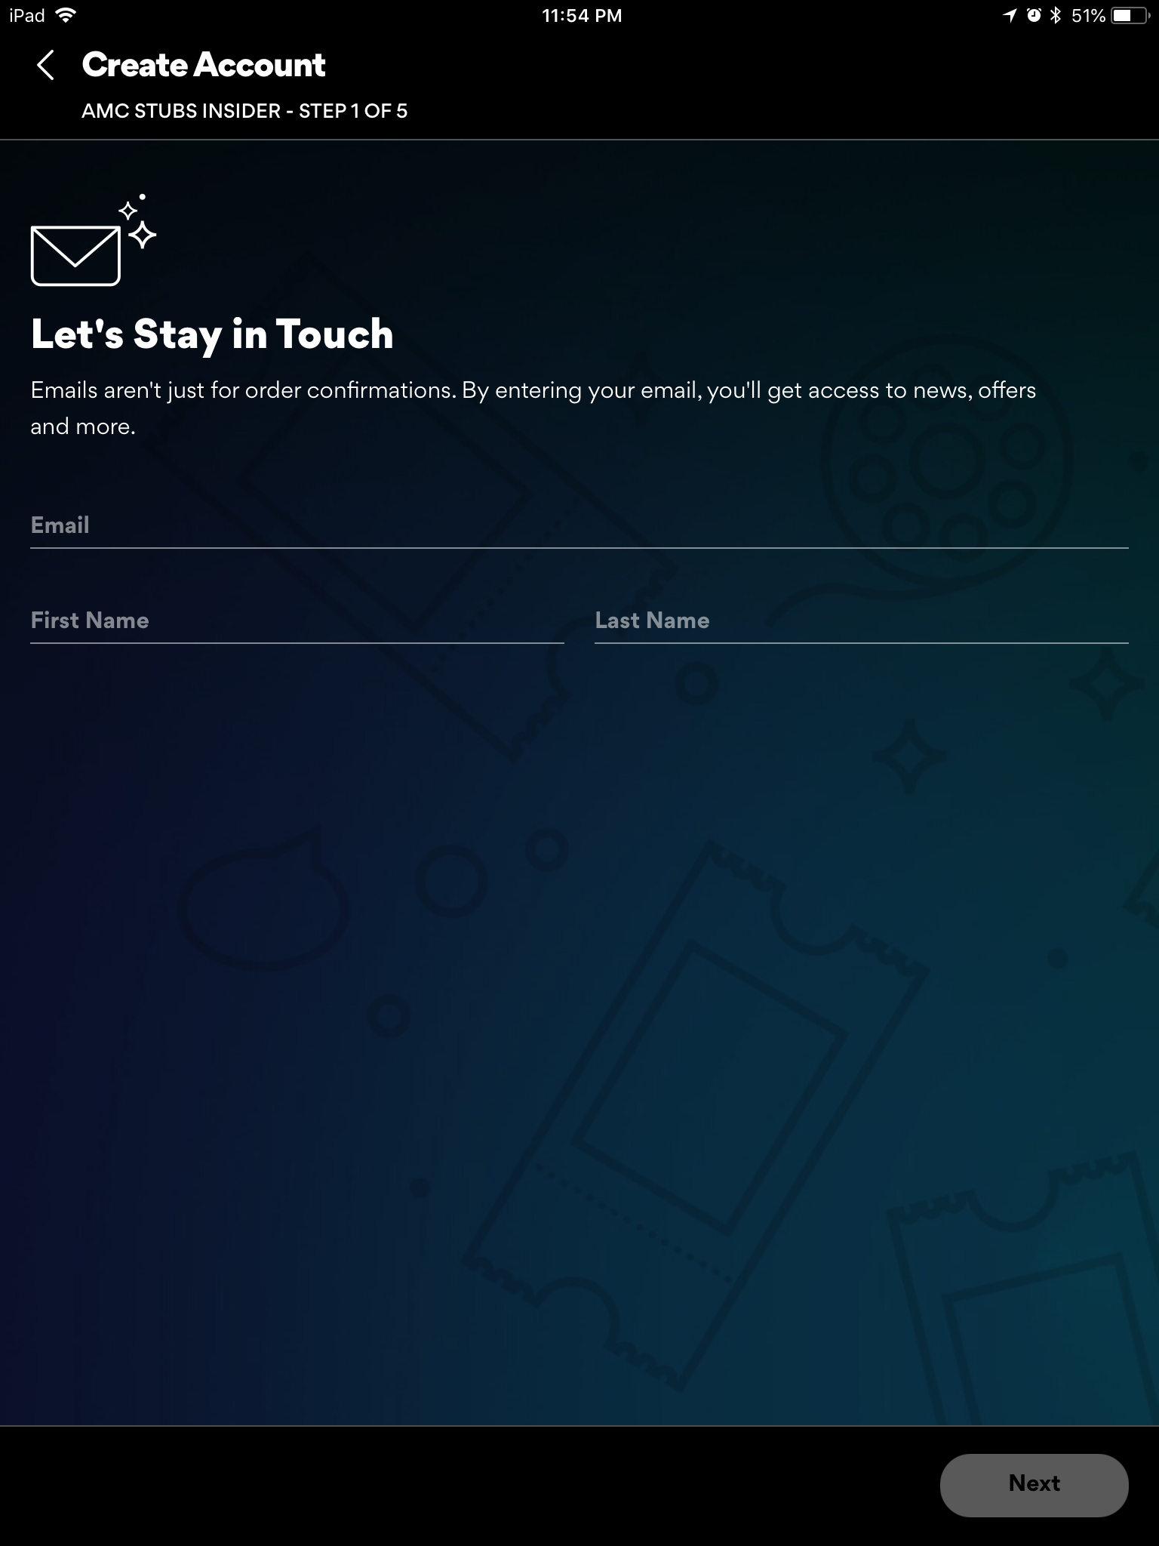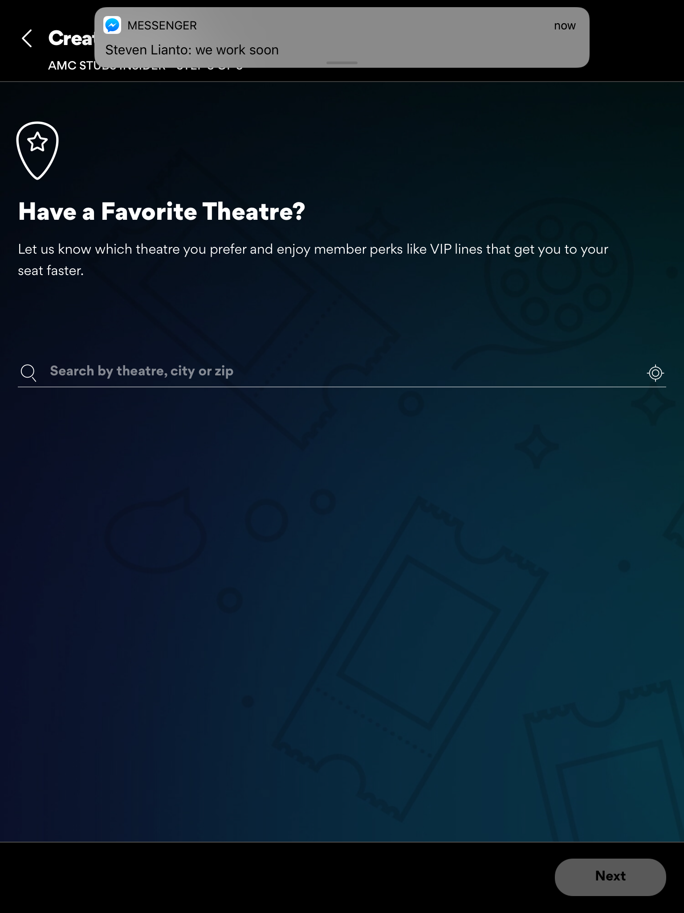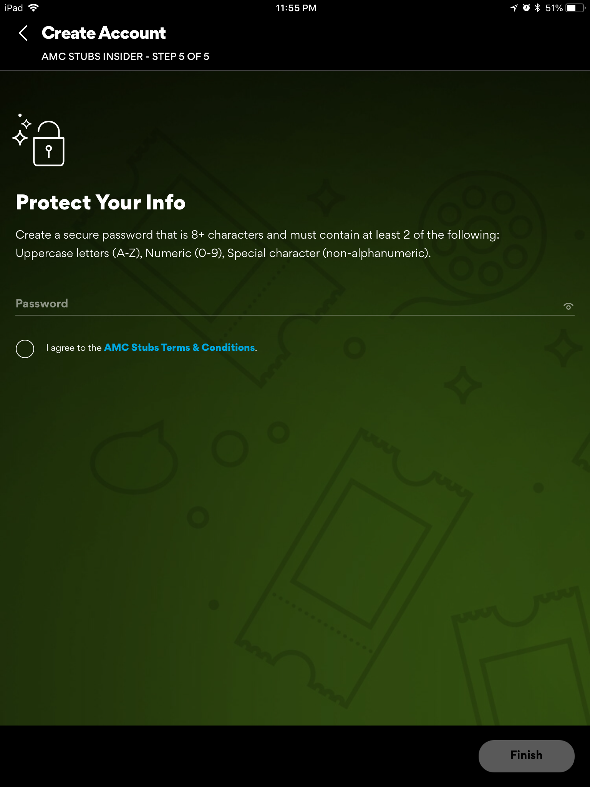

### Input domain

To start a new membership, users need to finished 10 steps by entering their personal information including their email address, name, birthday, favorite theatre (area) and a phone number(optional). After entering all valid information, a new membership is created.

|  |  |  |
| --- | --- | --- |
| **Input Value Description** | **Steps to Take** | **Explanation of Expected Outputs** |
| Input: JohnDoe for email  Description: invalid email address | 1. Click My AMC 2. Click Join Now 3. Click Join Free 4. Enter email | Expected output: Error message for invalid email address  Explanation: Because the email address the user entered is not valid, the system prompts error message and ask for re-enter |
| Input: yihua93@gmail.com for email address  Description: valid email address | 1. Click My AMC 2. Click Join Now 3. Click Join Free 4. Enter email | Expected output: No error message  Explanation: Since the email address is valid, the system continues and wait for user to enter other information |
| Input: empty string for names field  Description: invalid name | 1. Click My AMC 2. Click Join Now 3. Click Join Free 4. Enter valid email 5. Enter empty string in name fields | Expected output: Error message for invalid name  Explanation: Because the name that the user entered is not valid, the system prompts error message and ask for re-enter |
| Input: John Doe  Description: valid name | 1. Click My AMC 2. Click Join Now 3. Click Join Free 4. Enter valid email 5. Enter valid name 6. Click Next | Expected output: No error message  Explanation: Since the email address and name fields are valid, the system continues and wait for user to enter other information |
| Input: August 4, 2016 for birthday  Description: invalid date for birthday | 1. Click My AMC 2. Click Join Now 3. Click Join Free 4. Enter valid email 5. Enter valid name 6. Click Next 7. Enter birthday | Expected output: Error message for invalid birthday  Explanation: Because the birthday that the user entered is not valid, the system prompts error message and ask for re-enter |
| Input: August 4, 2000  Explanation: valid birthday | 1. Click My AMC 2. Click Join Now 3. Click Join Free 4. Enter valid email 5. Enter valid name 6. Click Next 7. Enter valid birthday 8. Click Next | Expected output: No error message  Explanation: Since the email address and name fields are valid, the system continues and wait for user to enter other information |
| Input: 000 for zip code  Explanation: invalid zip code | 1. Click My AMC 2. Click Join Now 3. Click Join Free 4. Enter valid email 5. Enter valid name 6. Click Next 7. Enter valid birthday 8. Click Next 9. Enter zipcode | Expected output: Error message for invalid zip code  Explanation: Because the zip code that the user entered is not valid, the system prompts error message and ask for re-enter |
| Input: 95112 for zip code  Explanation: valid zip code | 1. Click My AMC 2. Click Join Now 3. Click Join Free 4. Enter valid email 5. Enter valid name 6. Click Next 7. Enter valid birthday 8. Click Next 9. Enter zipcode 10. Enter Next | Expected output: No error message  Explanation: Since the email address and name fields are valid, the system continues and wait for user to enter other information |

### Membership Decision State Diagram

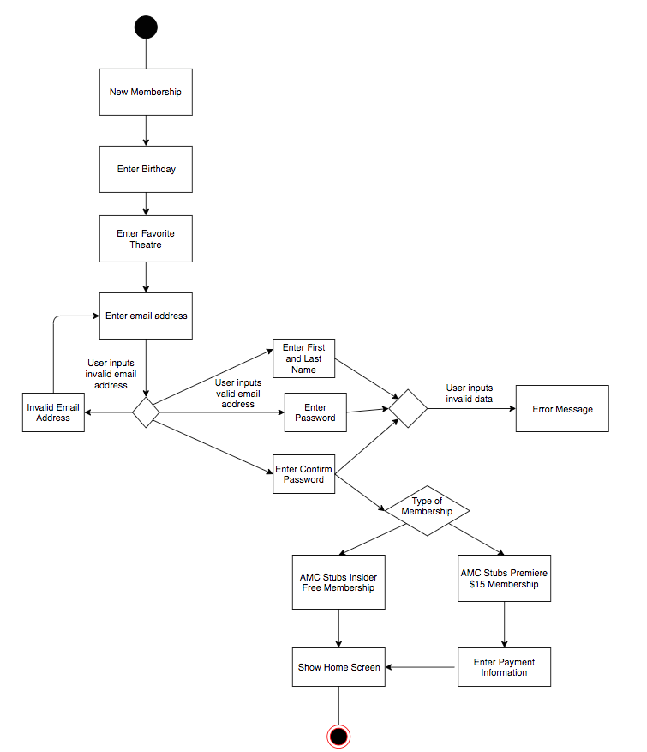

### 

### **Test Cases**

|  |  |  |  |  |  |
| --- | --- | --- | --- | --- | --- |
| # | Test Case | Inputs | Expected Output | Actual Output | Test Pass/Fail |
| 1. | Check for invalid email address | JohnDoe | Invalid email address | Invalid email address | Pass |
| 2. | Check for invalid password | AbC | Invalid password | Invalid password | Pass |
| 3. | Check for valid email address | lee93@gmail.com | No error message | No error message | Pass |
| 4. | Check for valid password | M0vie!Forever | No error message | No error message | Pass |
| 5. | Check for invalid name | “”(empty) | First/Last name is required | First/Last name is required | Pass |
| 6. | Check for valid name | John Doe | No error message | No error message | Pass |
| 7. | Check for invalid birthday | Apr 29, 2010 | User must be at least 13 years old | You must be at least 13 years old | Pass |
| 8. | Check for valid birthday | Jan 1, 1999 | No error message | No error message | Pass |
| 9. | Check for invalid zip code | 0001 | No results found | There aren’t any AMC theatres in that area, enter a new zip code | Pass |
| 10. | Check for valid zip code | 95112 | List of nearby AMC theatres | List of nearby AMC theatres | Pass |

## 

## Logging In

|  |  |
| --- | --- |
|  |  |

### Input Domain

|  |  |  |
| --- | --- | --- |
| **Input Value Description** | **Steps to Take** | **Explanation of Expected Outputs** |
| Input: superman500.mail  Description: The user may have entered an invalid email | 1. Tap on Sign-In 2. Enter Email 3. Enter Password 4. Tap Sign-In | Expected Output: Error Message  Explanation: The email does not match any valid account name. Check the email you have put in or password. |
| Input: [jaculina_chelsea@yahoo.com](mailto:jaculina_chelsea@yahoo.com)  Description: The user may enter a valid but unregistered email | 1. Tap on Sign-In 2. Enter Email 3. Enter Password 4. Tap Sign-In | Expected Output: Error  Message  Explanation: The email has not been registered to any account. |
| Input: abc123  Description: The user may have entered an invalid password | 1. Tap on Sign-In 2. Enter Email 3. Enter Password 4. Tap Sign-In | Expected Output: Error Message  Explanation: Invalid password for account. Reset option is available. |
| Input: Awesome1995!  Description: The user may have entered the correct password | 1. Tap on Sign-In 2. Enter Email 3. Enter Password 4. Tap Sign-In | Expected Output: User logs on.  Explanation:  The password is valid and matches with the email data. The user can log in. |

### Logging in Decision State Diagram

### 

### Test Cases

|  |  |  |  |  |  |
| --- | --- | --- | --- | --- | --- |
| # | Test Case | Inputs | Expected Output | Actual Output | Test Pass/Fail |
| 1. | Check for invalid email address | superman500.mail | Invalid email address | Invalid email address | Pass |
| 2. | Check for valid email address | [jaculina_chelsea@yahoo.com](mailto:jaculina_chelsea@yahoo.com) | No error message | No error message | Pass |
| 3. | Check for unregistered, but valid email address | Email: [diskwnri@gmail.com](mailto:diskwnri@gmail.com)  Password: abcdef | Sign In Failed | Sign In Failed | Pass |
| 4. | Check for incorrect password | Email: [superman500@gmail.com](mailto:superman500@gmail.com)  Password(incorrect): 123456 | Sign In Failed | Sign In Failed | Pass |
| 5. | Check for valid account | Email: [superman500@gmail.com](mailto:superman500@gmail.com)  Password(correct): M0vie!Forever | Redirect to profile page | Redirect to profile page | Pass |

## 

## 

## Browsing for Movie

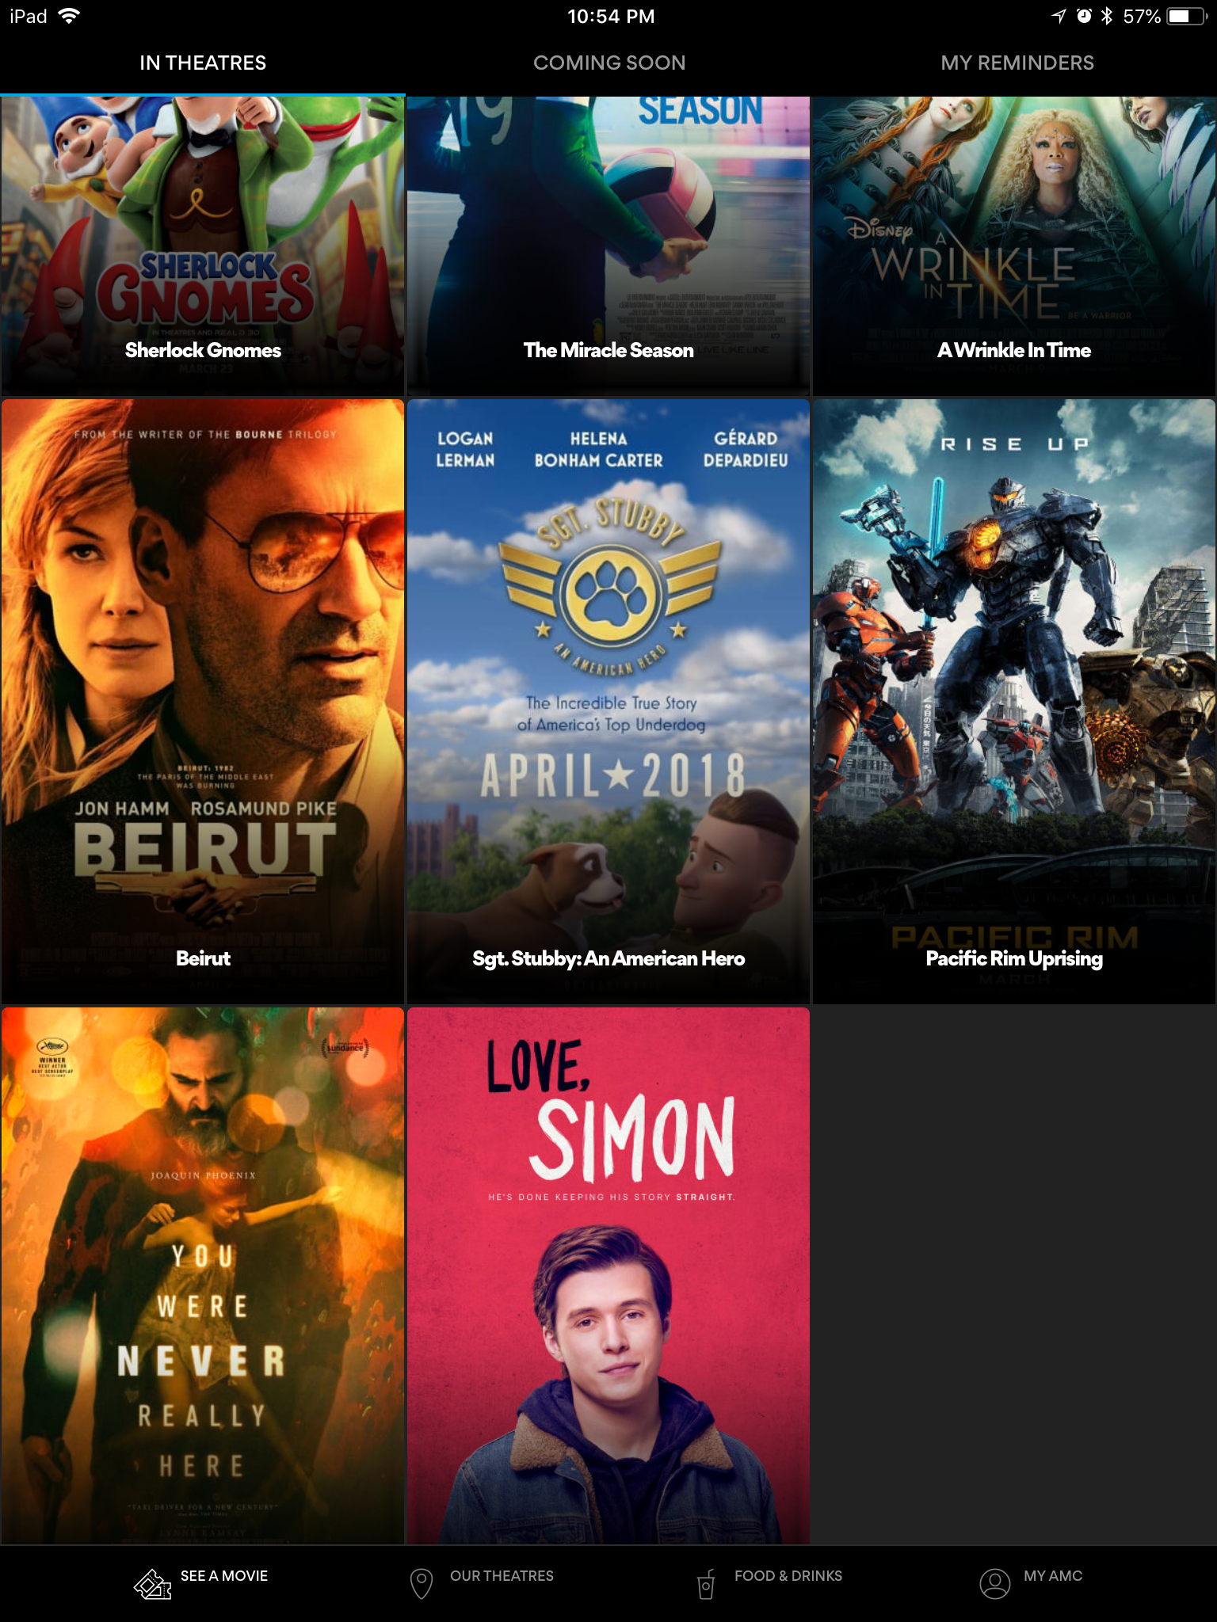

### Input Domain

​

The user doesn’t need to input anything for choosing a movie. However, the application requires to know the location of the user, so that will be considered the input. The user may also choose from theaters close to his/her location after providing a city or area code (Only works in USA). Boundary values aren’t present in this feature, however, equivalence partitioning is possible. The equivalence partitioning include: theaters close to user and theaters not close to user.

|  |  |  |
| --- | --- | --- |
| **Input Value Description** | **Steps to Take** | **Explanation of Expected Outputs** |
| Input: Current Location  Description: This theater is auto-selected from the user’s location obtained by the application and the user expects to choose a theater in that location. | 1. Select movie in logged In screen 2. Look/Choose Theater options | Expected Output: App shows movies in nearby theaters  Explanation: The app detects this location and display theaters in the area only. |
| Input: 100000  Description: The user may enter an invalid zip code | 1. Select movie in logged In screen 2. Look/Choose Theater options 3. Select choose location 4. Enter zip code | Expected Output: Error Message  Explanation: Invalid zip code. |
| Input: 95112  Description: The user inputs a valid zip code | 1. Select movie in logged In screen 2. Look/Choose Theater options 3. Select choose location 4. Enter zip code | Expected Output: Theater list shown on screen  Explanation: The user enters a valid zip code which now shows all theaters close to the area in the zip code |
| Input: New Delhi  Description: The user may enter a city which does not partner with AMC | 1. Select movie in logged In screen 2. Look/Choose Theater options 3. Select choose location 4. Enter city name | Expected Output: Error Message  Explanation: City does not partner with AMC theaters |
| Input: San Jose  Description: The user inputs a valid city name | 1. Select movie in logged In screen 2. Look/Choose Theater options 3. Select choose location 4. Enter city name | Expected Output: Theater list shown on screen  Explanation: The user enters a valid city name which now shows all theaters close to the area in the city |
| Input: shdfhg  Description: The user inputs an invalid city name | 1. Select movie in logged In screen 2. Look/Choose Theater options 3. Select choose location 4. Enter city name | Expected Output: Error Message  Explanation: Not a valid city name |

### Equivalence Partitioning Table

|  |  |
| --- | --- |
| **Equivalence Partitioning Class** | **Result** |
| Movie theaters close to user location | Theaters appear on the list |
| Movie theaters not close to user location | Theaters don’t appear on the list |

### Test Cases

|  |  |  |  |  |  |
| --- | --- | --- | --- | --- | --- |
| # | Test Case | Inputs | Expected Output | Actual Output | Test Pass/Fail |
| 1 | User is in the location and expects a theater in the location | Location: Current Location | Show theaters around that area only | -Century 20 Great Mall -AMC Mercado 20 -Camera 3  -CineArts at Santana Row -AMC Eastridge 15 ... | Pass |
| 2 | User is in a location but wants a theater in a different location | Location: 100000 | Error Message | Error Message | Pass |
|  | User is in a location but wants a theater in a different location | Location: 95112 | Show theaters around that area only | -Century 20 Great Mall -AMC Mercado 20 -Camera 3  -CineArts at Santana Row -AMC Eastridge 15 ... | Pass |
| 3 | User inputs an city name outside of USA | Location: New Delhi, India | Error Message | -Century 20 Great Mall -AMC Mercado 20 -Camera 3  -CineArts at Santana Row -AMC Eastridge 15 ... | Fail |
| 4 | User doesn’t allow the app to know his/her location | Location: None | Show message asking to allow to know location | “You must enable your GPS to use MoviePass” | Pass |
| 5 | User inputs an invalid location | Location: shdfhg | Error Message | Error Message | Pass |

## 

## Buying a Movie Ticket (without payment)

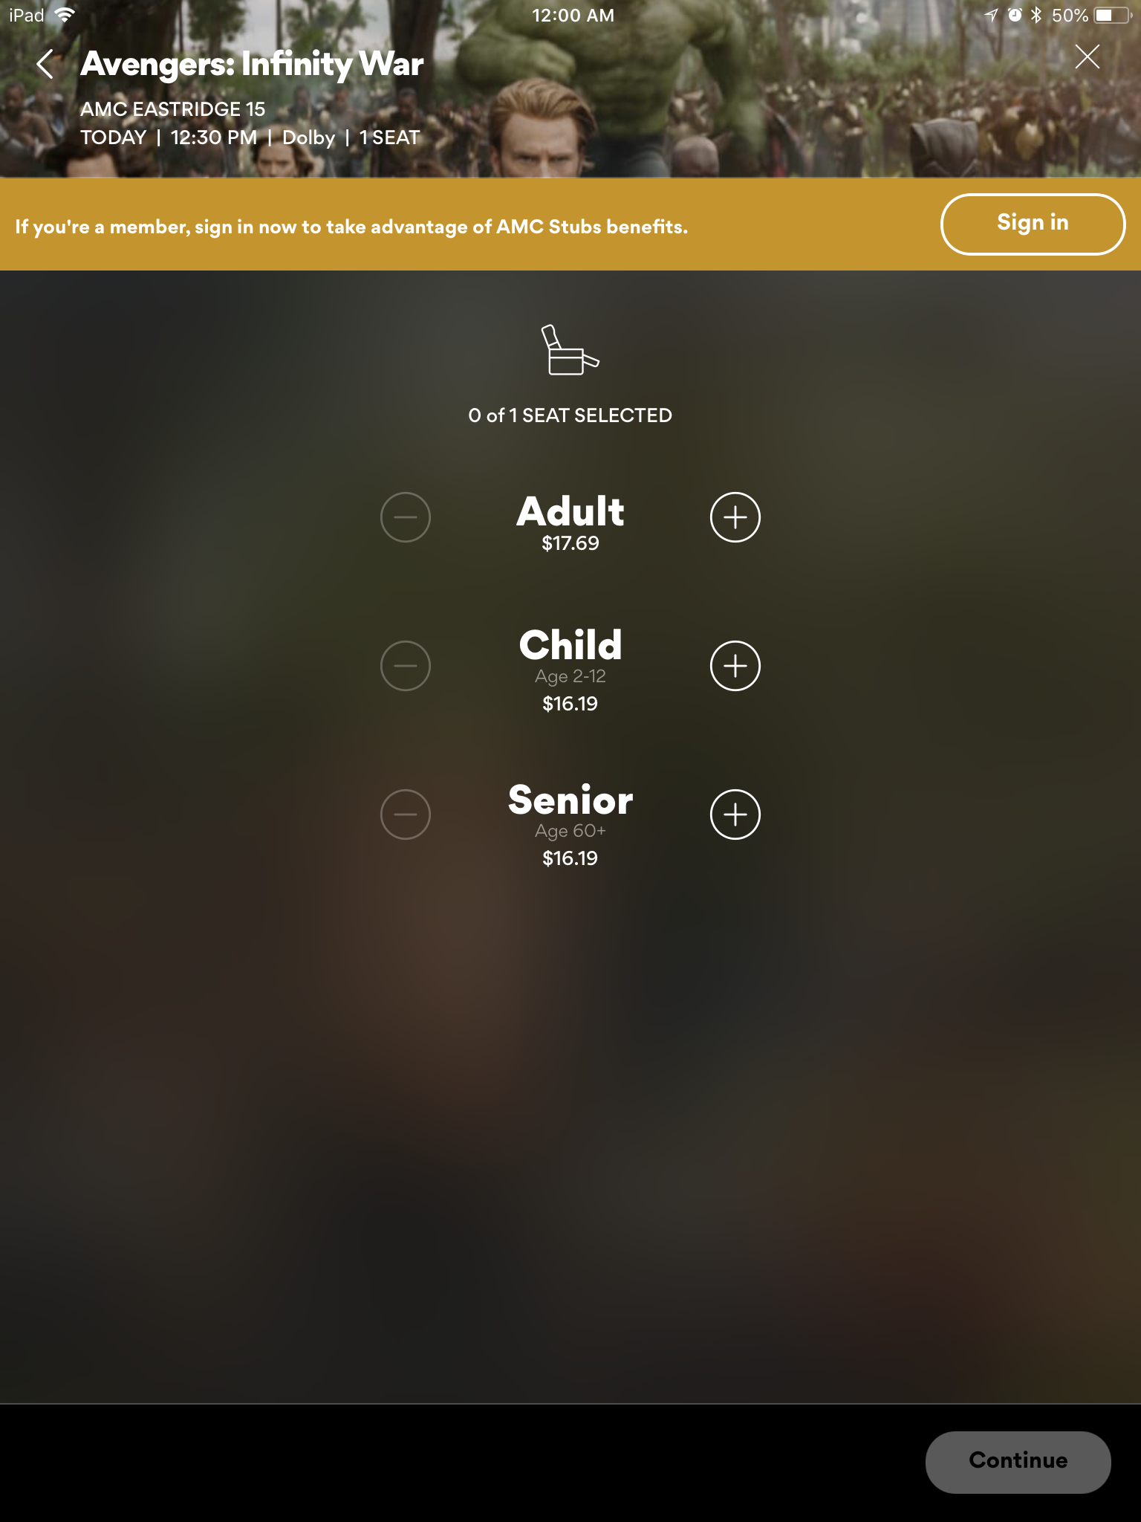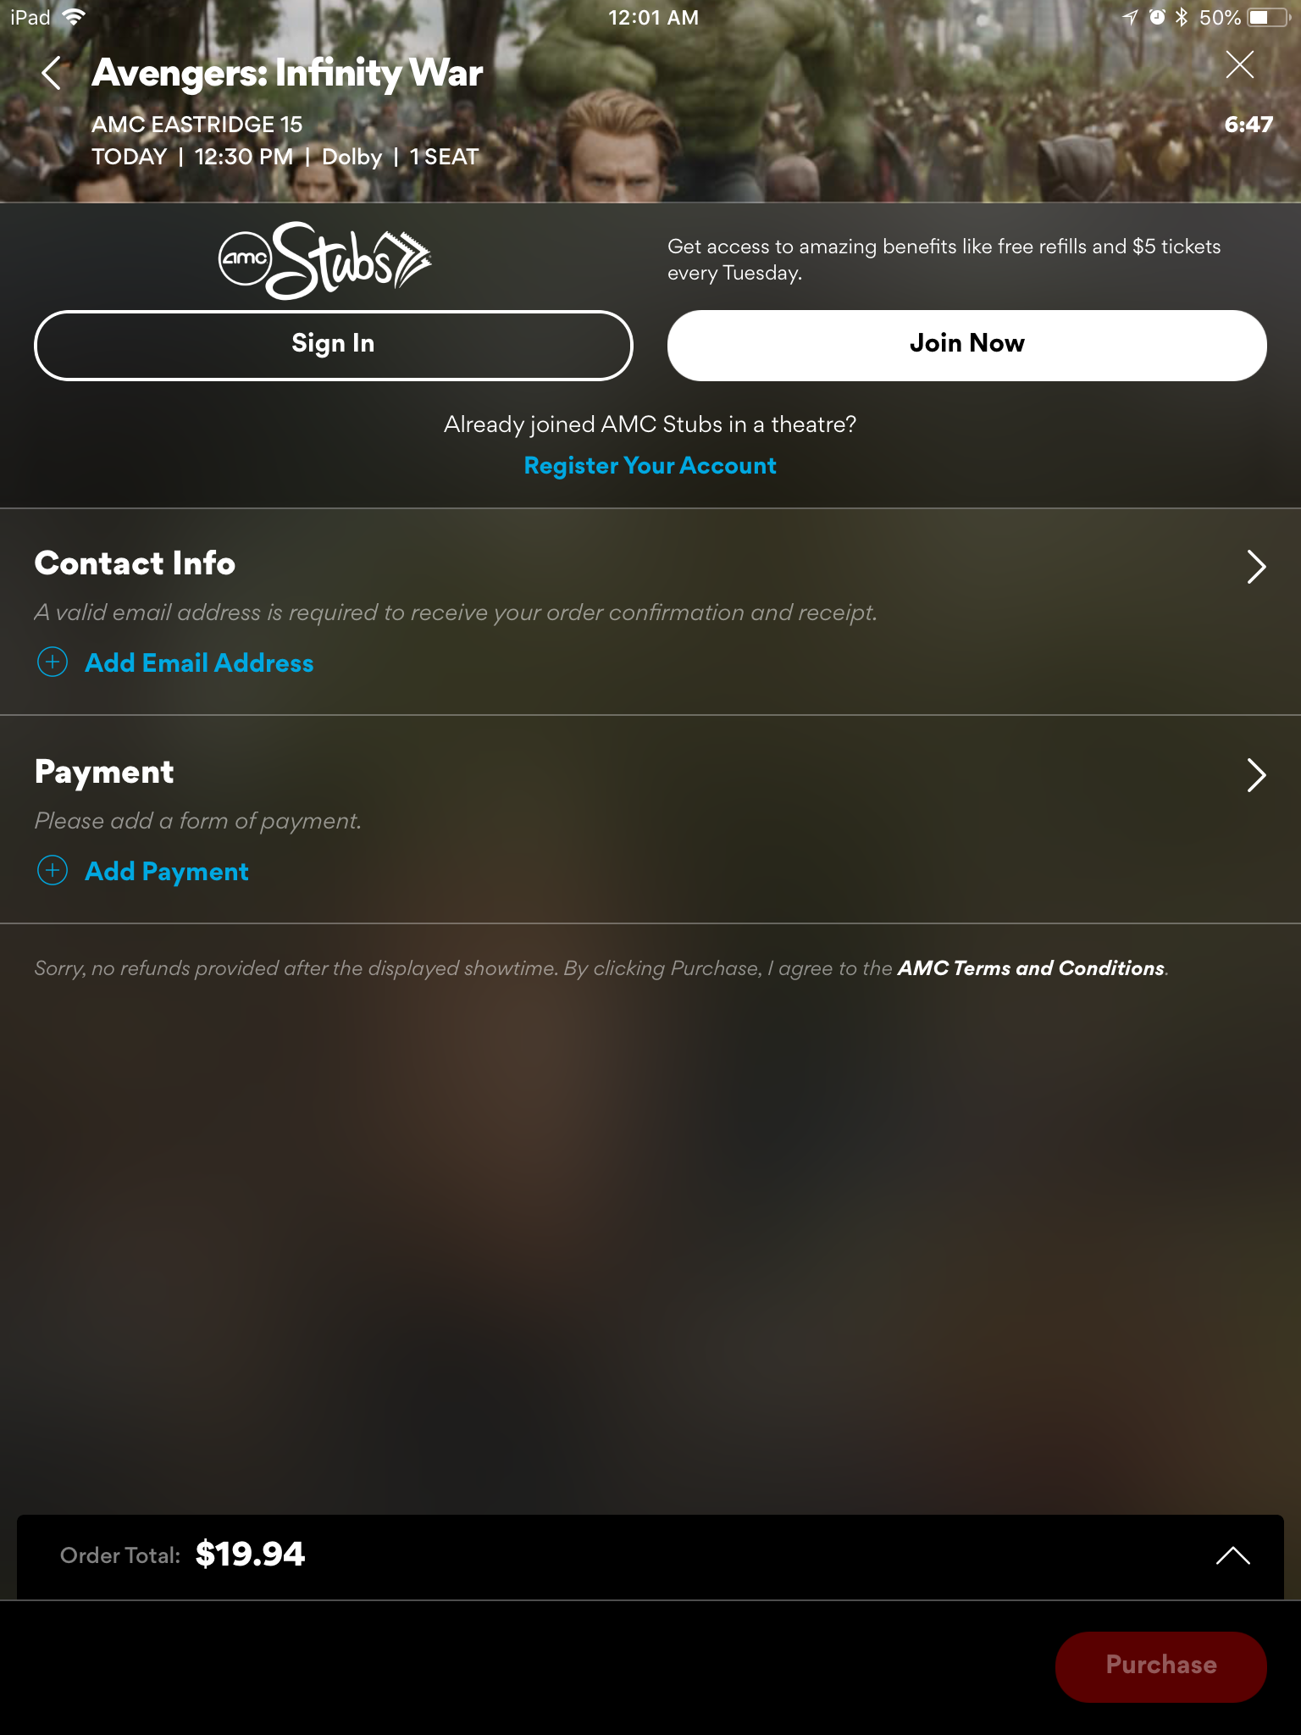

### Input Domain

After choosing a movie to watch, the user adjusts several filters to find the ticket suitable for him/her. The user chooses to buy n-number to tickets for either adults, children or elders. Finally, he is greeted with an order confirmation that will complete his order. There are boundary values and equivalent class partitioning classes.

|  |  |  |
| --- | --- | --- |
| **Input Value Description** | **Steps to Take** | **Explanation of Expected Outputs** |
| User chooses to buy 4 adults ticket for Avengers Infinity Wars | 1. Choose the movie 2. Choose the date 3. (Optional) Choose theatre 4. Choose movie time and type 5. Select number of tickets 6. Enter payment information 7. Confirm Order | 1. Order confirmed and user gets 4 tickets 2. Order failed due to system error 3. Order failed due to payment error 4. Order canceled due to user cancellation half-way |
| User is very busy and looks for all theatres that have Dolby for Avengers on Friday at 11:00pm | 1. Choose the movie 2. Scrolls through the list and search for 11pm showtime under Dolby | 1. Finds an available showtime and buys ticket 2. Cannot find this showtime and leaves app |
| User buys 2 tickets with a gift card instead of credit card | 1. Choose the movie 2. Choose the date 3. (Optional) Choose theatre 4. Choose movie time and type 5. Select number of tickets 6. Enter gift card 7. Confirm Order | 1. Gift Card works and final credit card charge is offset by gift card. 2. Gift Card fails and user is warned and take back to adding gift cards. |

### Equivalent Class

### Age and Ticket Price

|  |  |
| --- | --- |
| **Age** | **Boundary** |
| 2-12 | $16.19 |
| 13-50 | $19.19 |
| 50+ | $17.69 |

### Boundary Values

### Age and Ticket Price

|  |  |
| --- | --- |
| **Age** | **Boundary** |
| 2-12 | 2-12 |
| 13-50 | 13-50 |
| 50+ | 50+ |

### Test Cases

|  |  |  |  |  |  |
| --- | --- | --- | --- | --- | --- |
| # | Test Case | Inputs | Expected Output | Actual Output | Test Pass/Fail |
| 1. | User click on a movie that has no more available schedules | Clicks on the movie | *Greyed out past times* | Greyed out past times | Pass |
| 2. | User click on a movie theater that is full | Clicks on the movie | Sold out | Sold out | Pass |
| 3. | User chooses to buy 2 adult tickets | Chooses 2 adult tickets | Confirm order | Confirm order | Pass |
| 4. | User chooses the day he wants to buy a movie ticket | Tue, May 8 | *Shows on May 8* | Sorry, no showtimes have been announced yet for this theatre. | Fail |
| 5. | User chooses the location to buy the movie ticket | AMC Eastridge 15 | AMC Eastridge 15 | AMC Eastridge 15 | Pass |

## Screenshot/GUI Transition

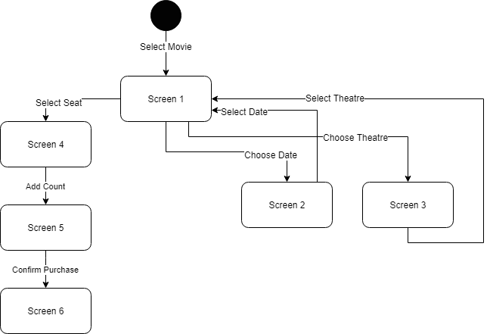

|  |  |  |
| --- | --- | --- |
|  |  |  |
| Scene 1 | Scene 2 | Scene 3 |
|  |  |  |
| Scene 4 | Scene 5 | Scene 6 |

# 

# Lessons Learned

There were many lessons that our team learned during this project. The first lesson included our team learning how to navigate through the mobile app that we chose, AMC Theatres. Since the AMC Theatres application is based on booking movie tickets for any specific AMC theatre, every team member needed to learn how each of their features worked. We all had to become familiar and comfortable with how to start a membership, log-in, choose an AMC movie theatre location, and how to book a movie ticket. The next lesson that our team learned was how to generate a list of features that we wanted to test, describe each of their input domains, and explain if any equivalent partitioning was necessary. Another important lesson that our team encountered was how to create test cases for each of the features and thoroughly explain the input values, necessary steps, and expected outputs. In addition, to these lessons, we had to figure out if our test cases resulted in a pass or fail. Lastly, we also learned how to determine if any transition diagrams, boundary values, equivalent partitioning, screenshots/GUI transition, or decision tables needed to be included. By performing Featuring Testing on a mobile based application such as AMC Theatres, we learned the overall importance of the technique in software quality assurance.